Module One Activity

Michael Surdek
Southern New Hampshire University
QSO 640: Project Management
Dr. Randy Butler
August 1, 2021

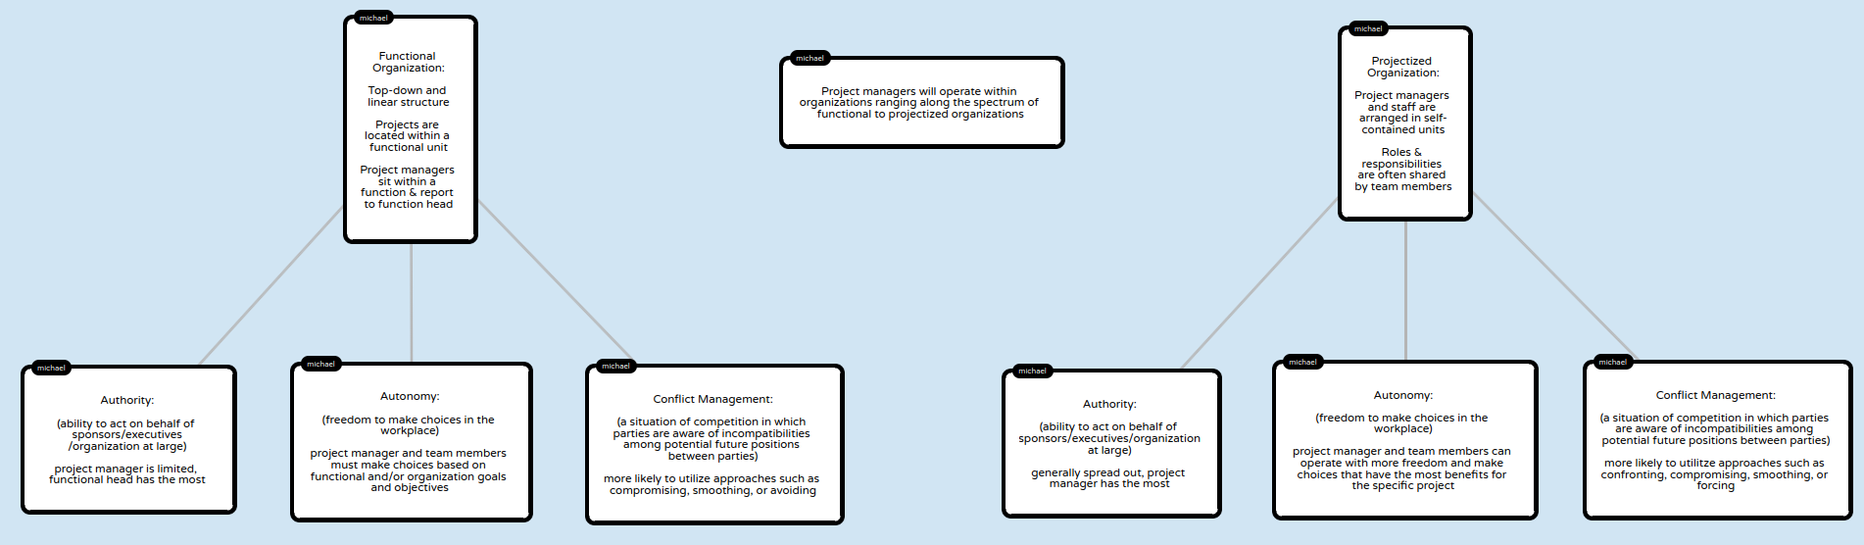

References:

“Module One: Project Management and the Role of the Project Manager.” 2014. MindEdge Inc. Retrieved from https://snhu.mindedgeonline.com/content.php?cid=87447

Ohlendorf, Amy. 2001. Conflict Resolution in Project Management. University of Missouri – Saint Louis. Retrieved from https://www.umsl.edu/~sauterv/analysis/488_f01_papers/Ohlendorf.htm

